Prayer after the Civil War, by Rabbi Sabato Morais (8 December 1865)
Contributor: | Aharon N. Varady (transcription) via the Open Siddur Project
Shared on: | 2022-08-18 10:15:52 under the <a href='https://creativecommons.org/licenses/by-sa/4.0/'>Creative Commons Attribution-ShareAlike (CC BY-SA) 4.0 International</a> copyleft license
Categories: | War | United States of America |
Stable Link | https://opensiddur.org/?p=46217
[xyz-ihs snippet="Table-Options"]
Contribute a translation | Source (English)
 | Merciful Creator! How dreary the vastness of the universe would appear to us without the light Thou sheddest upon it. How soon, at the hiding of Thy countenance, would all that charms our vision wither and all flesh decay; but Thou art beneficent, and carest for the beings to whom Thou hast given existence. For their sake Thou daily renewest Thy work, and, so wisely directest it, that it transcends not the limits Thou hast assigned thereto.
 | The refulgent luminaries and the dew-drop equally benefit the earth and its inhabitants. The surging billows and the piercing wind influence alike the abode of man. Therefore have the creatures of Thy love come before Thee for thanksgiving; for under Thy paternal guidance was this country gladdened with exuberance of food. Thou didst cover us under Thy protecting wings, and at thy rebuke pestilence hied away. Thus providentially shielded, we found energy to apply the mind to high callings. The vast fields of science were tended, and they rewarded human endeavors. General knowledge was diffused, and the institutions of public education received adequate support.
 | Thou hast also, O God! vouchsafed to bless the precious inheritance of our fathers. Thou hast enlarged, strengthened and greatly enhanced its value in the eyes of the world. Oh, may we every revolving year exult over the attainment of the same blessings; over the health and plenty we enjoyed; over the freedom granted to all men of North America, and over the peace of the Union.
 | And now we beseech Thee, O Lord! to inspire us with brotherly love, that we may be drawn together into one indissoluble bond. Uphold the counsel of our rulers, that it may be directed to the work of human civilization. Endow our Chief Executive with wisdom to frustrate the schemes of evil doers, and with capacity to fulfill the longings of the good. And may the boon of civil and religious liberty hasten the day when Thou shalt be acknowledged the only King and Lord in heaven and upon earth. Amen.

This prayer by Rabbi Sabato Morais was offered (possibly for Thanksgiving Day) in conclusion to a sermon delivered at some point prior to its printing in The Philadelphia Inquirer on 8 December 1865. It was preserved by Rabbi Morais in his ledger (page 24, clipping 030), an archive of newsclippings recording material he contributed to the press, among other announcements. (Many thanks to the Library of the University of Pennsylvania for helping to make this resource accessible.) Above the clipping, Rabbi Sabato has written, "Andrew Johnson proved anything but a worthy successor to the sainted Abraham Lincoln."

Source(s)
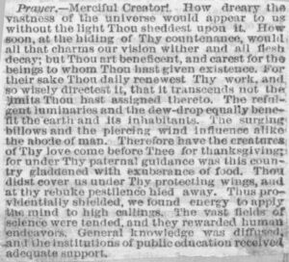
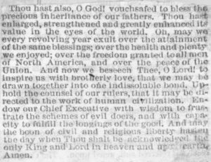
[caption id="attachment_46218" align="alignleft" width="300"]Prayer [1865-12-08] (Sabato Morais Ledger, p. 24, clipping 030) - a[/caption] [caption id="attachment_46219" align="alignnone" width="300"]Prayer [1865-12-08] (Sabato Morais Ledger, p. 24, clipping 030) - b[/caption][su_spacer]

