Prayer of the Guest Chaplain of the U.S. House of Representatives: Rabbi Abraham J. Feldman on 29 January 1958
Contributor: | Abraham J. Feldman via the Open Siddur Project
Shared on: | 2024-02-19 16:25:54 under the <a href='https://creativecommons.org/publicdomain/zero/1.0/'>Creative Commons Zero (CC 0) Universal license</a> a Public Domain dedication
Categories: | Opening Prayers for Legislative Bodies | United States of America |
Stable Link | https://opensiddur.org/?p=54349
Guest Chaplain: Rabbi Abraham J. Feldman, D.D., Temple Beth Israel, Hartford, Connecticut Date of Prayer: 29 January 1958 Sponsor: Rep. Edwin May (R-CT)
[xyz-ihs snippet="Table-Options"]
Contribute a translation | Source (English)
 | O God, author of all that is, who transcendeth space and time— and yet art nigh unto all that call upon Thee sincerely, humbly we bespeak Thy blessing upon these representatives of the people of this Republic. Sanctify their purposes as they serve their people and Thee and hallow their lives as they give of themselves in dedication.
 | Reverently, O God, we call unto Thee for Thy blessing to rest upon the Government of this Republic and upon all who govern by the consent of this people. Strengthen and sustain their will to righteousness.
 | Give unto all of us, O God, the inspiration to goodness, the courage of righteousness, the daring of soaring hopefulness, the warmth of profound conviction, the humility of continuing faithfulness.
 | Above all, O God, give us the assurance— at once comforting and challenging— that we are ever in Thy presence, that Thine eye is ever upon us and that Thine arm continues to guide us.
 | O Father, as we direct unto Thee “the fruit of our lips” and the meditations of our hearts, be pleased to “incline Thine ear unto us, to hear our words, and wondrously to show Thy steadfast love” unto all Thy children. Amen.

This prayer of the guest chaplain was offered in the first month of the second session of the 85th US Congress in the House of Representatives. The source images of the prayer were copied by Howard Mortman and shared via his @CongressRabbi Twitter account. All credit to Howard Mortman for his research in digging up this prayer. Unfortunately, neither the source images nor his tweets provide an exact citation reference to the volume, issue, and page number of the Congressional Record in which the prayer was published. If you know, leave a comment, or contact us.

Source(s)
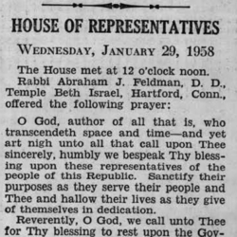
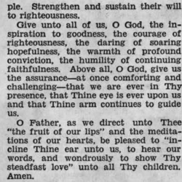
[caption id="attachment_54350" align="alignleft" width="250"]Prayer of the Guest Chaplain (Abraham J. Feldman, 29 January 1958) - a[/caption] [caption id="attachment_54351" align="alignleft" width="250"]Prayer of the Guest Chaplain (Abraham J. Feldman, 29 January 1958) - b[/caption][spacer]

