Prayer of the Guest Chaplain of the U.S. House of Representatives: Rabbi Isidore Lewinthal on 17 January 1917
Contributor: | Isidore Lewinthal via the Open Siddur Project
Shared on: | 2024-01-13 19:39:25 under the <a href='https://creativecommons.org/publicdomain/zero/1.0/'>Creative Commons Zero (CC 0) Universal license</a> a Public Domain dedication
Categories: | Opening Prayers for Legislative Bodies | United States of America |
Stable Link | https://opensiddur.org/?p=53929
Guest Chaplain: Rabbi Isidore Lewinthal, of Vine Street Temple, Nashville, Tennessee Date of Prayer: 17 January 1917 House of Representatives
[xyz-ihs snippet="Table-Options"]
Contribute a translation | Source (English)
 | O Lord God, to Thee do we come in this hour and ask for Thy guidance. Do Thou grant wisdom and understanding to the Members of this House, so that they may acquit themselves of and discharge their duties as fully as their hearts desire to do so.
 | We thank thee, O Lord, that the lines have been cast to us in pleasant places. We have indeed a goodly heritage. We stand upon a shore unshaken, to look out upon the nations of the earth that are rocked and tossed as a ship upon the sea bestormed. We are in peace, while they are in tumult; we are without blood, while they are walking in garments rolled in blood. O do Thou grant that these struggles may speedily tend toward peace.
 | We beseech Thee that Thou wilt unite the hearts of men together in common citizenship; may they be inspired with a common desire for purity, for uprightness, for integrity in civil things.
 | O grant that in this great Nation there may be none that shall shrink from duty, none shall fear to speak and act for truth and for liberty.
 | Grant that evil be smitten down and pierced through and destroyed, justice established, purity in the place of corruption stand forth, and all nations see the beginning of Thy salvation in the midst of this people.
 | Into Thy keeping do we commend the President of these United States, the Speaker of this House, the Members of this Congress, and all the constituted authorities, so that through them order may be preserved and right and liberty be fostered.
 | And Thine alone, O God, shall be the praise and glory, now and evermore. Amen.

This prayer of the guest chaplain was offered at the tail end of the 64th US Congress, before the United States had officially entered World War Ⅰ. The source images of the prayer were copied by Howard Mortman and shared via his @CongressRabbi Twitter account. All credit to Howard Mortman for his research in digging up this prayer. Unfortunately, neither the source images nor his tweets provide an exact citation reference to the volume, issue, and page number of the Congressional Record in which the prayer was published. If you know, leave a comment, or contact us.

Source(s)
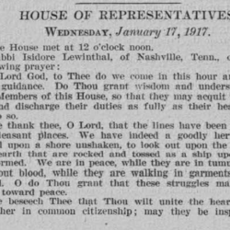
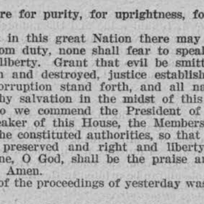
[caption id="attachment_53932" align="alignleft" width="250"]Prayer of the Guest Chaplain for the US House of Representatives (Isidore Lewinthal, 17 February 1917) - a[/caption] [caption id="attachment_53933" align="alignnone" width="250"]Prayer of the Guest Chaplain for the US House of Representatives (Isidore Lewinthal, 17 February 1917) - b[/caption][spacer]

