The Last Tishah b'Av: A Tale of New Temples, by Rabbi Arthur Ocean Waskow and Rabbi Phyllis Ocean Berman (2006)
Contributor: | Arthur Waskow via the Open Siddur Project
Shared on: | 2014-07-28 17:24:05 under the <a href='https://creativecommons.org/licenses/by-sa/4.0/'>Creative Commons Attribution-ShareAlike (CC BY-SA) 4.0 International</a> copyleft license
Categories: | Modern Miscellany | Tishah b'Av Readings |
Stable Link | https://opensiddur.org/?p=9252
[caption id="attachment_9259" align="aligncenter" width="857"]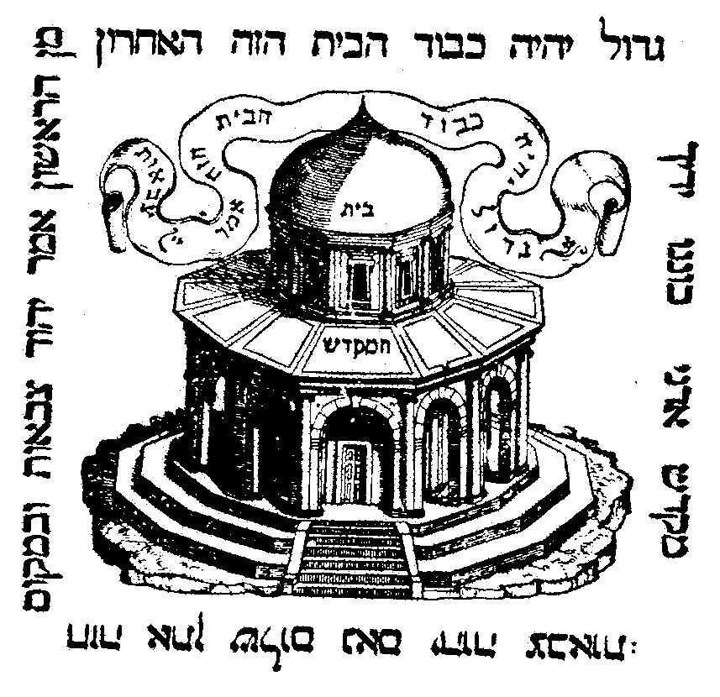The Temple in Jerusalem depicted as the Dome of the Rock on the printer's mark of Marco Antonio Giustiniani, Venice 1545–1552[/caption] [xyz-ihs snippet="Table-Options"]
Contribute a translation | English
 | To the hills of Israel where the air is clearest and it is possible to see the furthest --
 | To the little town of Tz’fat, which some call Safed -- above the Lake Kinneret in the Galilee —
 | Long ago there came a Ḥassid, visiting from Vitebsk to see his Rebbe.
 | Struggling up hills, over cobblestones, through narrow alleyways, the Ḥassid came panting, shaking, to the door of a pale and quiet synagogue.
 | So pale, so quiet was this shul that the pastel paintings on the wall and ceiling stood out as though they were in vivid primary colors.
 | As the Ḥassid came into the shul, he saw his Rebbe high on a make-shift ladder, painting a picture on the ceiling above the bimah.[foot]Above the bimah in the Rabbi Isaac Aboab Synagogue in Safed, there is actually a painting of the Dome of the Rock. I saw it there in 1969. See also Encyclopedia Judaica under “Safed,” vol.14, p. 631, figure 4. -- Arthur Waskow[/foot]
 | The Ḥassid blinked, startled to see his Rebbe with a paint brush in his hand.
 | And then he blinked again. He frowned and tugged at his beard:
 | “Rebbe, what is this that you are painting here above the bimah? It looks like the Dome that the Children of Ishmael, the ones they call Muslims, have built above the rock where Abraham bound Isaac.
 | “The giant golden Dome that they have built where stood the Holy Temple. I have just come from Jerusalem… It looks…” He stopped.
 | The Rebbe’s eyes turned inward. “You know,” he said, “Here in Tz’fat we live in the radiance of the Kabbalists who lived and taught here many years ago. The air here is so clear and their radiance so pure that with our outer and our inner eyes we can see and see and see… so far! And I have seen…” he said, and paused. “I have seen…” he said and paused again.
 | “Looking and seeing, they can be so strange. For example — our sages teach us that when Mashiaḥ comes, he will rebuild the Holy Temple in the twinkling of an eye. But often have I wondered: How can this be? Mashiaḥ will be extraordinary, yet still a human being merely …
 | “But now! I have seen … Well, let me tell you: At the foot of the Western Wall, the Wall where God’s Own Presence weeps and hides in exile, I have seen hundreds of thousands of Jews gathered, singing.
 | “Mashiaḥ has come! — — and they are singing, dancing, as the Great Day dawns. Women, men, together — — I could not believe it! I was not even sure” — — he glanced apologetic at his Ḥassid — “whether Mashiaḥ was a wo- … well, forget it.
 | “I can see from the sun, the heat, it is late afternoon. Yet the crowd are wearing t’fillin. The only time in all the year when Jews wear t’fillin in the afternoon is Tishah b'Av, so I can see that it is the day of mourning for our beloved Temple. But there are no signs of mourning — — except perhaps the way, the wistful way, Mashiaḥ reaches out to touch the Wall, to tuck one last petition between the great carved stones.
 | “I see Mashiaḥ speak a sentence to the crowds. I cannot hear the words, but I can see that from this voice there stirs a river. Like water from the ancient stones of Wall, I see a stream of Jews flow up the stairway that rises to the Temple Mount.
 | “The river of people pauses on the steps. They cluster ‘round a wrinkled, tattered piece of paper, posted above the stairway. I see it is signed by the rabbis of that day. It warns all Jews to go no further, lest by accident they walk — — God forbid! — — into the space set aside as the Holy of Holies.
 | “Mashiaḥ reads. And laughs. And tears the sign to shreds. The stream of people shudders — — higher, higher.
 | “The crowd cascades from the stairway onto the great stone pavement of the Temple Mount. Their singing turns to the thunder of a great waterfall. They look toward the other end of the Mount — toward the great golden Dome of the Rock where Abraham bound his son for sacrifice.
 | “Surrounding the Dome are thousands of these children of Ishmael, these Muslims. They are not singing. They are shouting, furious, stubborn. ‘Not here!’ they shout in unison, ‘Not here!’
 | “ ‘You will not tear down our Holy Mosque to build your Jewish Temple!’
 | “But I can hear the crowd of Jews — — muttering, whispering, ‘Right there, yes! — — That is the place… No doubt, no doubt, the ancient studies tell us that it is the place.’
 | “Mashiaḥ is quiet. The sea of Jews falls to a murmuring, falls silent. They turn to watch. Mashiaḥ looks, gazes, embraces with fond eyes the Holy Space. Mashiaḥ’s eyes move across the Dome, its golden glow, the greens and blues and ivories of the walls beneath it.
 | I hear a whisper from Mashiaḥ’s lips: ‘So beautiful!’ “The Muslims too are silent now. The stillness here, the stillness there — — so total that they split the Holy Mount in two.
 | “Mashiaḥ raises one arrn, slowly, slowly. The Muslims tense, lift knives and clubs and shake them in the stillness. The Jews tense, ready to leap forward with their picks and shovels.
 | “Mashiaḥ points straight at the Dome.
 | “The peoples vibrate: two separate phantom ram’s horns in the silent air, wailing forth a silent sob to Heaven.
 | “Mashiaḥ speaks quietly into the utter quiet:
 | ‘This green, this blue, this gold, this Dome — — This is the Holy Temple!’
 | “I blink.
 | “For seconds, minutes, there is not a sound.
 | “Then I hear a Muslim shout, see him raise a knife: ‘No! No! You will not steal our Holy Mosque to make your Jewish Temple!”
 | “He throws the knife. It falls far short. No one stirs. The other Muslims turn to look at him. They look with steadfast eyes: no joy, no anger. They just keep looking. He wilts into the crowd; I can no longer see what he is doing.
 | ”Mashiaḥ steps forward, one step. Everyone, Jew and Muslim. breathes a breath. One Jew calls out: ‘You must not do this. You must not use their dirty place to be our Holy Temple. Tear it down! — — We need our own, the Prophets teach how wide and tall it is to be. It is not this thing of theirs, this thing of curves and circles.
 | “He takes a step toward Mashiaḥ, lifts an axe to brandish it.
 | “The man beside him reaches out a hand and takes the axe. Just takes it. There is a murmur. but the murmur dies. The man holds the axe level in both hands, walks out with it into the no-man’s land between the crowds. He lays it on the pavement next to the Muslim knife, he backs away.
 | “There is another time of quiet. Two Muslims reach out from the crowd, toss their knives to land next to the axe. The pause is shorter this time. Then on every side weapons come flying through the air to land beside the axe, beside the knives. There is a pile. Somehow -- I cannot see how -- there lights a fire. The pile begins to burn. The flames reach up and up and up - — to Heaven.
 | “So I have seen,” the Rebbe said, “Mashiaḥ build the Temple in the twinkling of an eye. And that is why I am painting this Dome upon our ceiling.”
 | The visitor took breath again. “And why?” he said. “Why would Mashiaḥ do this dreadful thing?”
 | The Rebbe put his arm around his Ḥassid’s shoulder.
 | “You still don’t see?” he said. “Even here in Tz’fat, you still don’t see?
 | “I think Mashiaḥ had four reasons:
 | “First for the sake of Abraham’s two families.
 | “Second for the sake of the spirals, twirling in the Dorne.
 | “Third for the sake of the Rock beneath the Dome.
 | “And fourth for the sake of the twinkling of an eye.”
 | ”And Rebbe — why did the people burn their weapons’?”
 | “For the sake of the burnt offering. It is written that when the Temple is rebuilt, there must be burnt offerings. And it is also written, ‘Choose!’
 | “Choose what? Choose what to burn:
 | “Each other, and the Temple, yet again?
 | “Or — — the things we use to burn each other with?”
 | “So …” said the Ḥassid, “… dear Rebbe — you are saying that the Dome — it really is our Temple?
 | “Forgive me, Rebbe, but I have a different seeing. Where they raised up the burnt-offering I think must be the Temple. The empty space. The empty space where the offering went up in flames to Heaven.
 | “The empty space between them, where they burned the weapons — — perhaps that is the Temple’?
 | “Ours and theirs?”
 | The Rebbe turned, astonished, to gaze more deeply into the Ḥassid's eyes.
 | And then together, each with an arm around the other’s shoulder, together they walked to where their eyes could look --
 | Far, far beyond the hills, much farther than the Lake they call Kinneret.

This year (2014), the Jewish Fast of Tishah b'Av (August 4-5) and its memory of bloodshed and destruction of the Holy Temple/s in Jerusalem comes in the midst of bloodshed between the two families of Abraham -- a destruction of the deeper moral Temple. In Jewish tradition, on this very day of disaster Mashiaḥ (Messiah) was born, but hidden away till a generation would come that is ready to make peace and eco-social justice in the world. So this year, we offer this story of hope and redemption to be read by Jews and Muslims together on the fast day or for the evening break-fast when it ends (August 5). For many other midrashic reinterpretations of Torah for our generation, see theshalomcenter.org. To help The Shalom Center keep creating such materials and organizing peace-building events, please DONATE.

