תפילה לשלום | صلاه لاجل السلام | A prayer for Peace (רוח גלילית Spirit of Galilee, 29 April 2024)

Author: Noa Mazor
Date: 2024-05-01 10:16:43
Last Updated: 2024-06-01 11:55:07
Categories: Slavery &amp; Captivity, War
Tags: 2023 Israel–Hamas war, 21st century C.E., 58th century A.M., ecumenical prayers, Needing Vocalization

Excerpt: This prayer for peace was written on 29 April 2024, at the end of Passover, by Rabbi Shira Levine as part of an ecumenical assembly, the "<a href="https://www.facebook.com/SpiritoftheGalilee">Spirit of Galilee</a>." The Arabic translation was made by Malek Hujerat.

This prayer for peace was written on 29 April 2024, at the end of Passover, by Rabbi Shira Levine as part of an ecumenical assembly, the "
Spirit of Galilee
." The Arabic translation was made by Malek Hujerat. The prayer was shared by Leora Ezrecha-vered,
via her Facebook page
on 30 April 2024, with the following message in Hebrew and English:
אתמול בלילה, כאשר קבוצת המנהיגות הבינדתית (המורכבת מאנשי ונשות דת יהודים, נוצרים, מוסלמים, דרוזים ואפילו בודהיסטית שחיים בגליל) בירכה זו את זה ב“תרבחו ותסעדו”, ברכנו זה את זו בשלום ורווחה. ומתוך השיחה עלתה יוזמה, שאז נכתבה, תורגמה והותאמה והנה היא. תפילה צנועה וקטנה לימים טובים יותר. תודה ל- Ghadir Hani שיזמה לרבה Shira Levine Shany שכתבה למאלכ חוג'יראת, איש מאמין ומשורר שתרגם. לרבה Noa Mazor שעיצבה ולכל אנשי ונשות Spirit of the Galilee רוח גלילית שהגיבו ותמכו. מהפינה הקטנה שלנו, של אנשי ונשות דת, שמובילים קהילות ועשייה יוצאת תפילה לחזרת החטופים והחטופות ולחיים של שקט על פני האדמה. אפשר וכדאי לשתף Last night our small but strong group of spiritual and religious leaders, under the banner of "Spirit of the Galilee," wrote a joint prayer. Our group consists of Jews, Christians, Muslims, Druze, and a Buddhist. Together we wrote a prayer for better days. Ghadir initiated it, Rabbi Shira Levin wrote the prayer, Malek Hujerat wrote the Arabic and Rabbi Noa Mazor designed it, and the whole group supported and commented. A group project. Please share.

Source(s)
[caption id="attachment_55726" align="alignnone" width="250"]

Prayer for Peace (Shira Levin, Spirit of Galilee, 2024, trans. Malek Hujerat)[/caption]

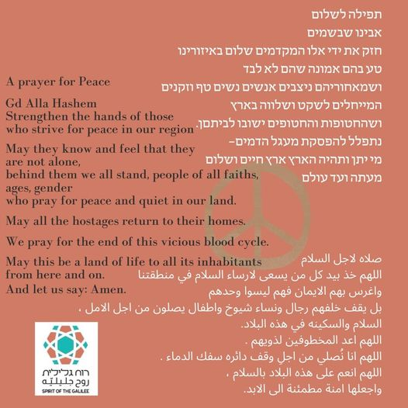
Image Title: Prayer for Peace (Shira Levin, Spirit of Galilee, 2024, trans. Malek Hujerat)
Image Caption: Prayer for Peace (Shira Levin, Spirit of Galilee, 2024, trans. Malek Hujerat)


Co-Author: Noa Mazor
Bio: Rabbi Noa Mazor (HUC Jer '16) Educator, inter-religious and peace activist.
Profile: https://opensiddur.org/profile/noa-mazor/


Co-Author: Shira Levine
Bio: Born in Jerusalem, Shira Levine and her family are now part of the pluralistic community living at Kibbutz Hanaton. Shira grew up in a Conservative congregation in Jerusalem and was active in the Noam youth movement and Ramah summer camps. After her army service she went on Shlichut to the Jewish community in Melbourne, Australia. She is an attorney, a graduate of the Law Faculty of the Hebrew University of Jerusalem and holds a graduate degree in Talmud and Gender Studies from the Solomon Schechter Institute of Jewish Studies. She has combined her legal work with widespread communal activity at the Tel Aviv Beit Tefilah Israeli, as well as for the Hanaton community. She leads lifecycle events and teaches and facilitates informal Jewish education programs at the Hanaton Educational Center, as well as at summer camps.
Website: https://www.hartman.org.il/person/shira-levine/
Profile: https://opensiddur.org/profile/shira-levine/

open_content_license: <a href='https://creativecommons.org/licenses/by-sa/4.0/'>Creative Commons Attribution-ShareAlike (CC BY-SA) 4.0 International</a> copyleft license

_thumbnail_id: 55726

_yoast_wpseo_primary_category: 1106

Source: https://opensiddur.org/?p=55725

